NATIONAL UNIVERSITY OF MODERN LANGUAGE ISLAMABAD
Lab 07


Submitted to:
Ms. Saadia Shabbir
Submitted by:
Zulqarnain Hassan
Roll No: …………………… SP21379
Subject: …………………… Web engineering
Department: ……………… BSSE-5-Afternoon
Date: ……………………… 18-11-2024

Lab Task
Create web pages on any emerging topic using positioning elements
Page 1
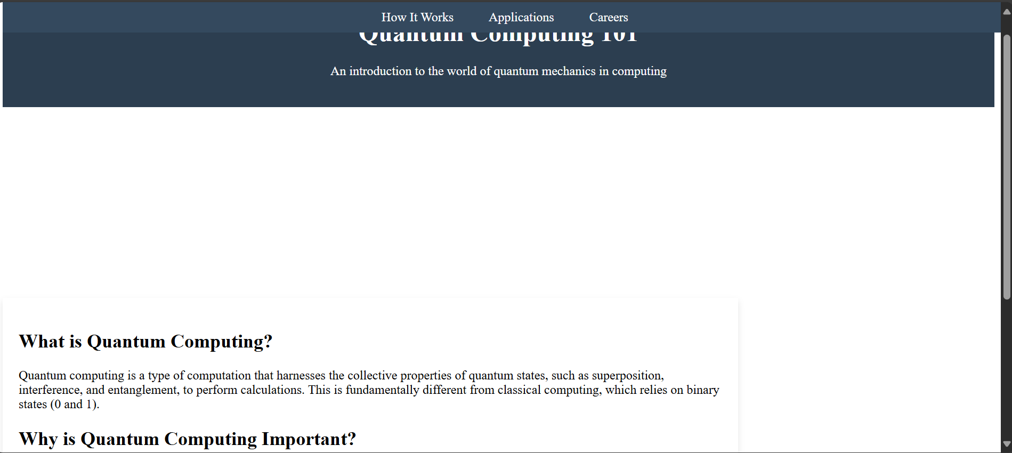

Page 2
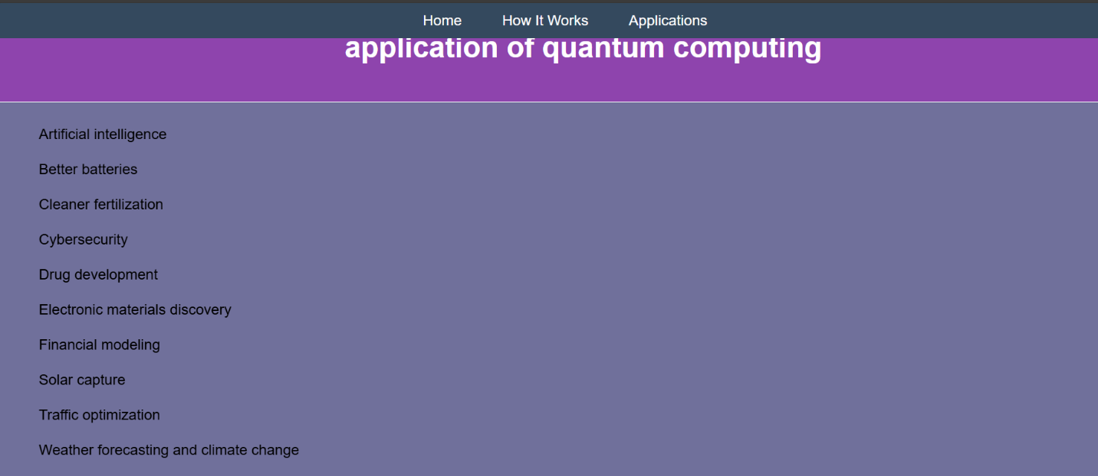

Page 3
